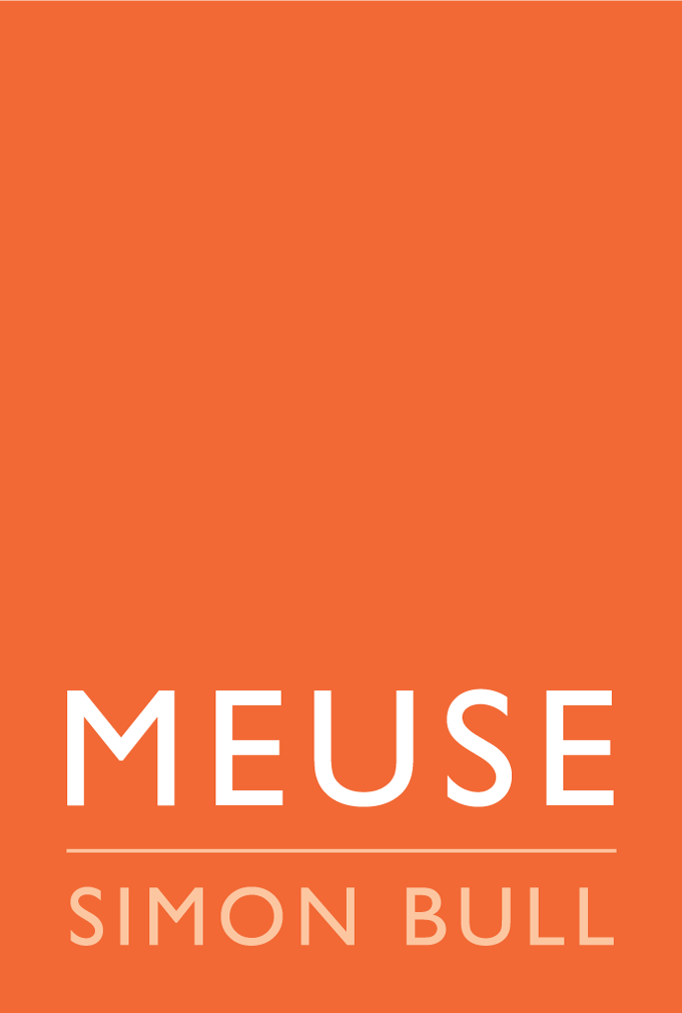
PRESS RELEASE: FOR IMMEDIATE RELEASE

SIMON BULL: A BREATH OF PLEIN AIR
SIMON BULL PAINTS CALIFORNIA
May 13th - 31st
Opening Reception with Artist Simon Bull: Sunday, May 15th, 2022. 6pm - 8pm

Carmel, CA. To celebrate the return of the Carmel Art Festival after the COVID outbreak, Artist Simon Bull will be premiering his first Plein Air Exhibition. While the artist's creative focus has been on his studio works over the years, their inspiration comes from his frequent excursions into nature. Simon's retreats into the landscape have produced a body of sketches, notebooks, and Plein Air paintings, many of which have never been available to the public until now.

Each MEUSE Gallery, located in Carmel-by-the-Sea & in Saint Helena, will present a curated collection of these works. The exhibition will run through the Carmel Art Festival until the end of May.

For more information, please contact: Gina Encerti, Director of MEUSE Gallery Carmel-by-the-Sea, Ocean & Monte Verde, Carmel-by-the-Sea, CA, 93923 | Email: gina@meusegallery.com | Mobile: 209-652-4729

