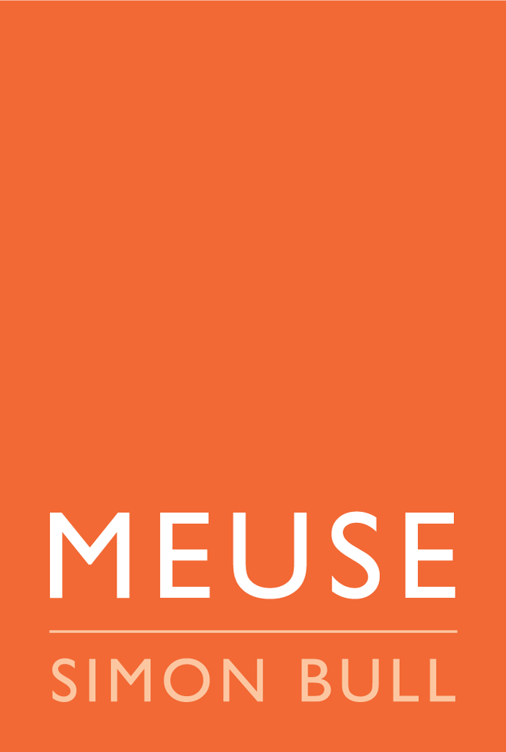
PRESS RELEASE: FOR IMMEDIATE RELEASE

SIMON BULL: THE FREE BIRDS OF LOCKDOWN
EXHIBITION AND BOOK LAUNCH
March 26th - April 30, 2022
Opening Reception: Saturday, March 26, 4pm - 6pm
Artist’s Talk and Q&A: 5pm

St Helena, CA. When the global pandemic first hit and lockdowns began, artist Simon Bull responded by giving away free art. Now, two years later, all 365 of the original brush and ink bird studies from that project have been cataloged in a new book: “The Free Birds of Lockdown”.
“During lockdown, the idea of creating bird studies anyone could claim online for free appealed to me. It was a kind of antidote to the palpable fear and loss of freedom that pervaded the world, or my way of saying: 'the human spirit can not be caged, not by disease, government mandate or economic collapse'. Each little bird was personally created with its own character and attitude using techniques reminiscent of Chinese brushwork.“ - Simon Bull.
MEUSE Gallery in St Helena will be premiering an exhibition of these original bird studies and hosting a book signing with the artist in person.
March 26th - April 30, 2022
Opening Reception: Saturday, March 26, 4pm - 6pm. Artist’s Talk and Q&A: 5pm.
Complimentary wine graciously supplied by HALL Wines.
For more information, please contact: Katherine Salinas, Director of MEUSE Gallery St Helena, 1331 Main St, St Helena, CA, 94574. Email: kat@meusegallery.com | Mobile: 831-224-3717

